4.1.2 CAMPUS SPORTS FACILITIES

Badminton Court Indoor - Image 1
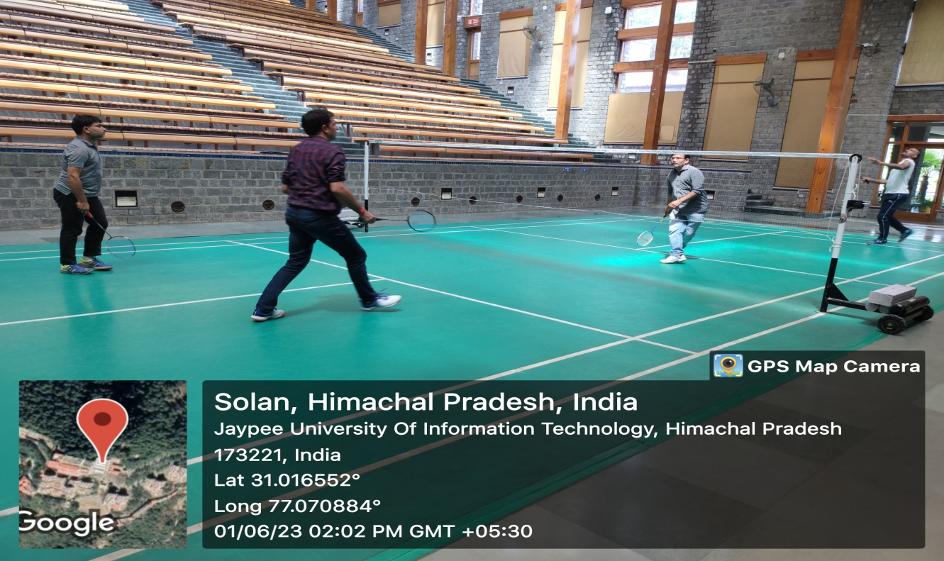
Badminton Court Indoor - Image 2
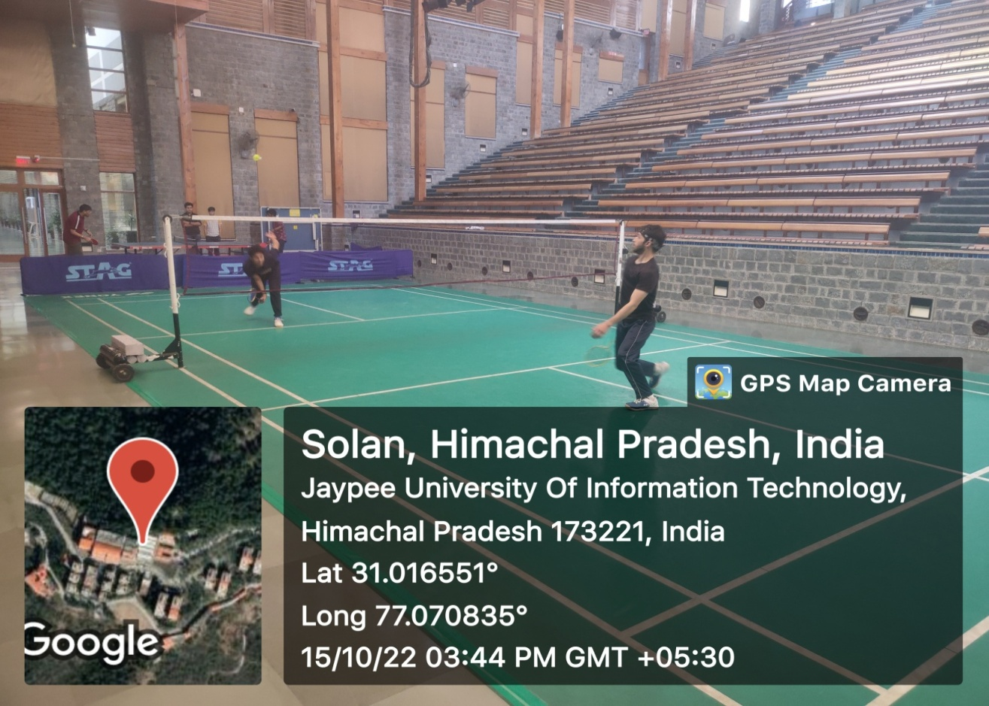
Badminton Court Outdoor – Image 1
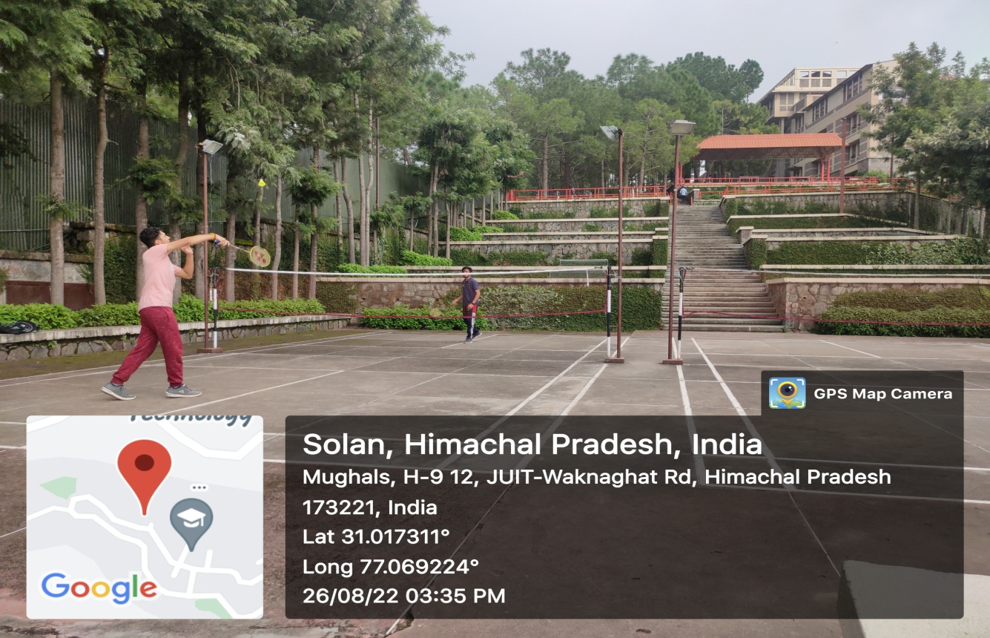

Badminton Court Outdoor – Image 2
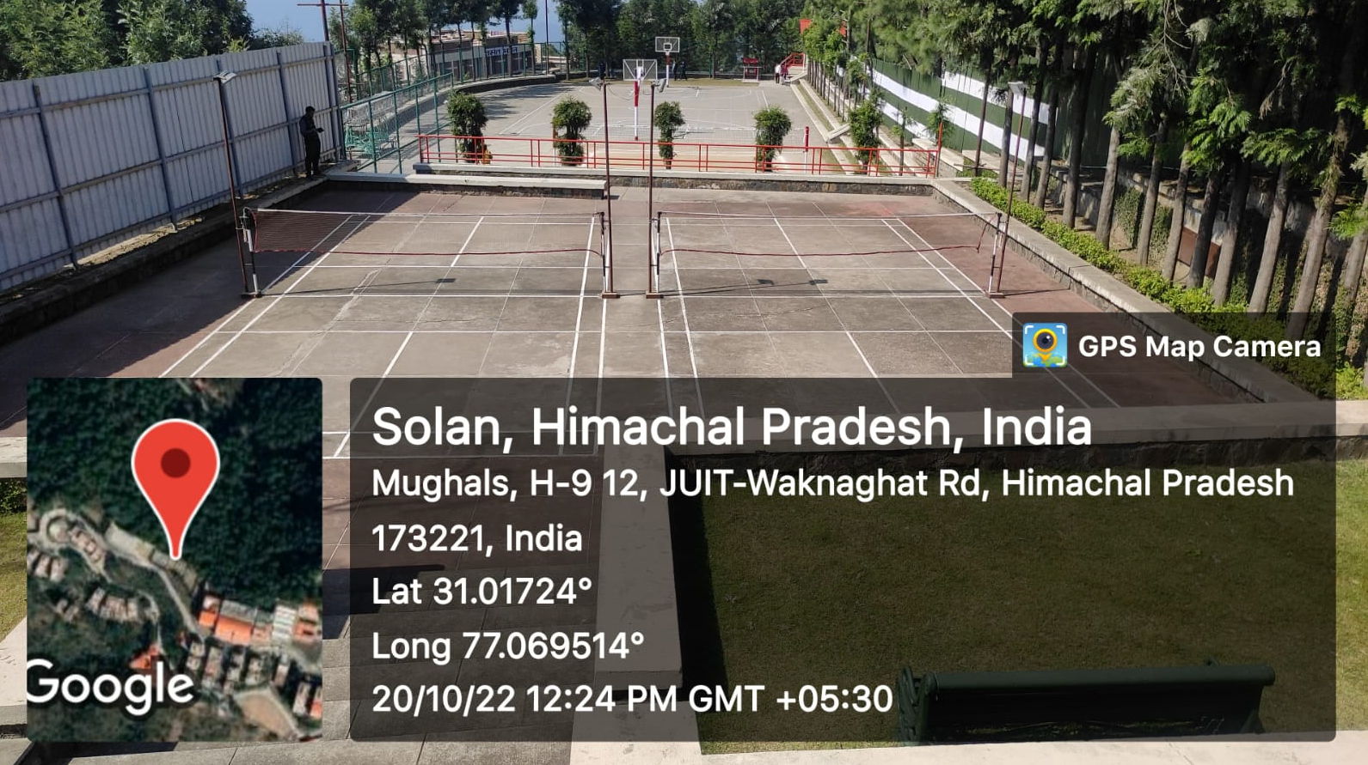

Basketball Court : Image 1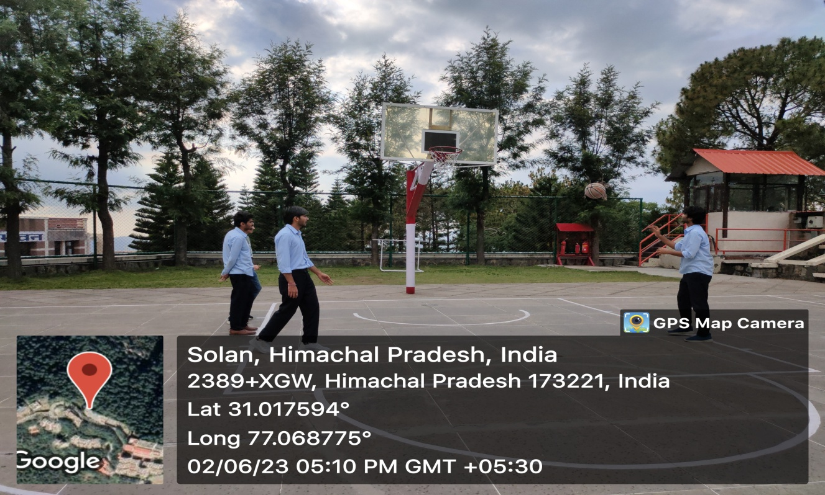

Basketball Court : Image 2
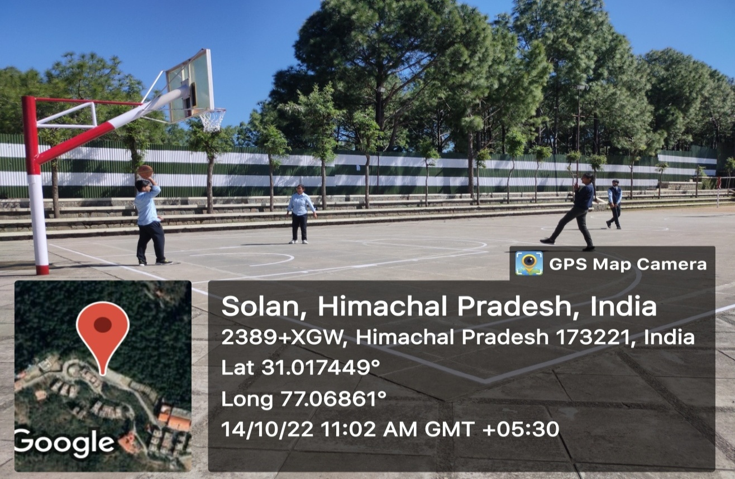

Carromboard Cum TV Lounge Room
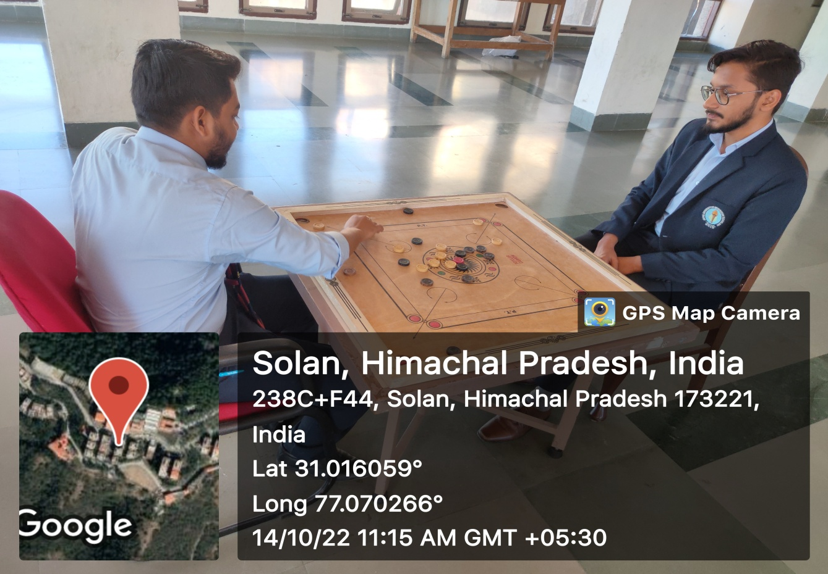

Cricket Net Practice Court – Image 1

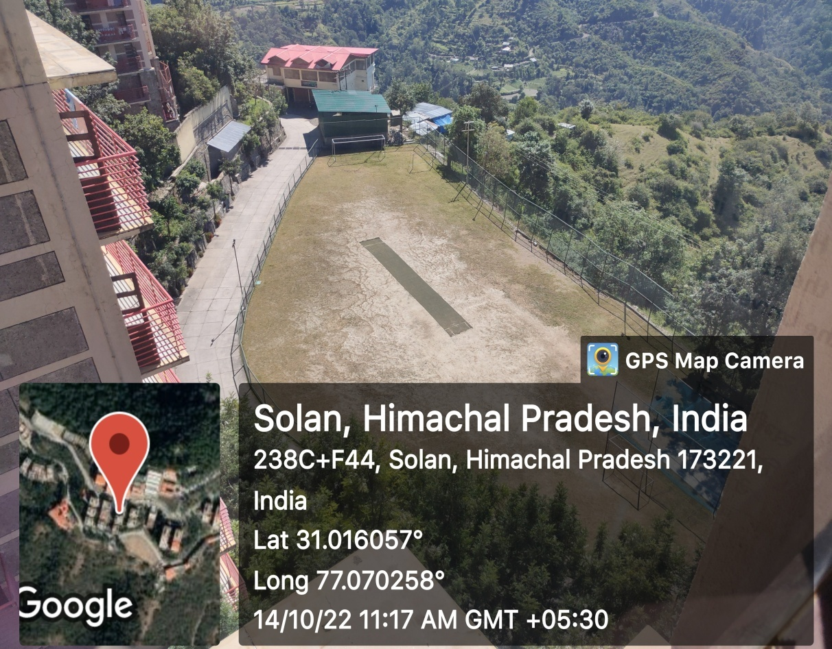
Cricket Net Practice Court – Image 2

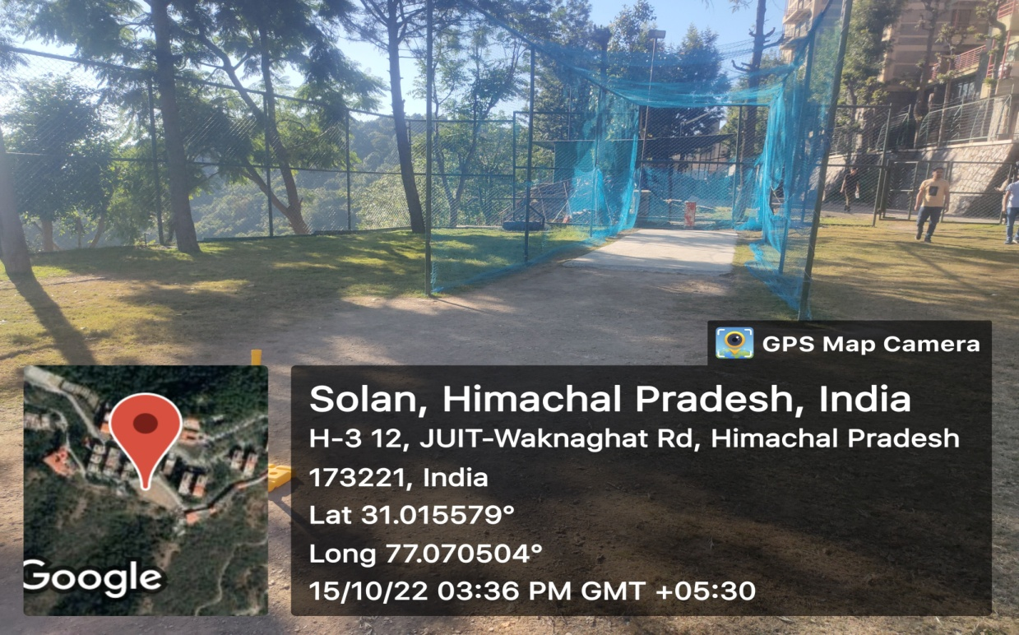

Football Court (Mini Ground – 7 Players aside) - Image 1

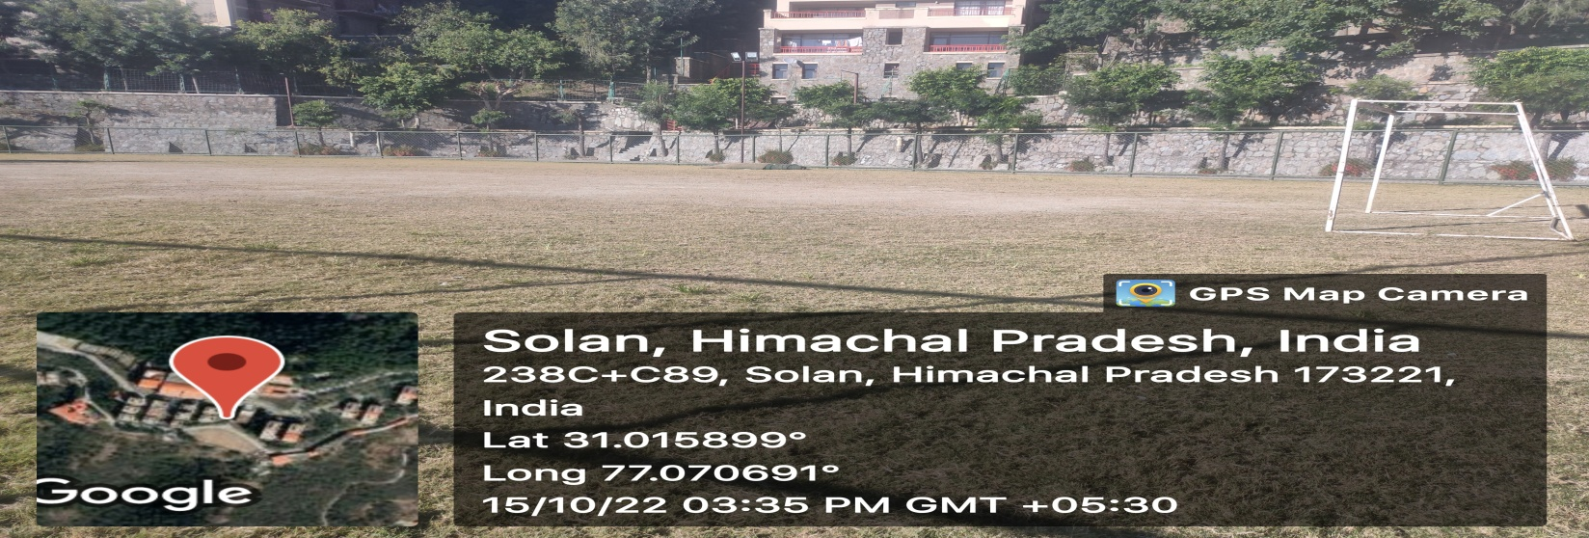

Football Court (Mini Ground – 7 Players aside) - Image 2

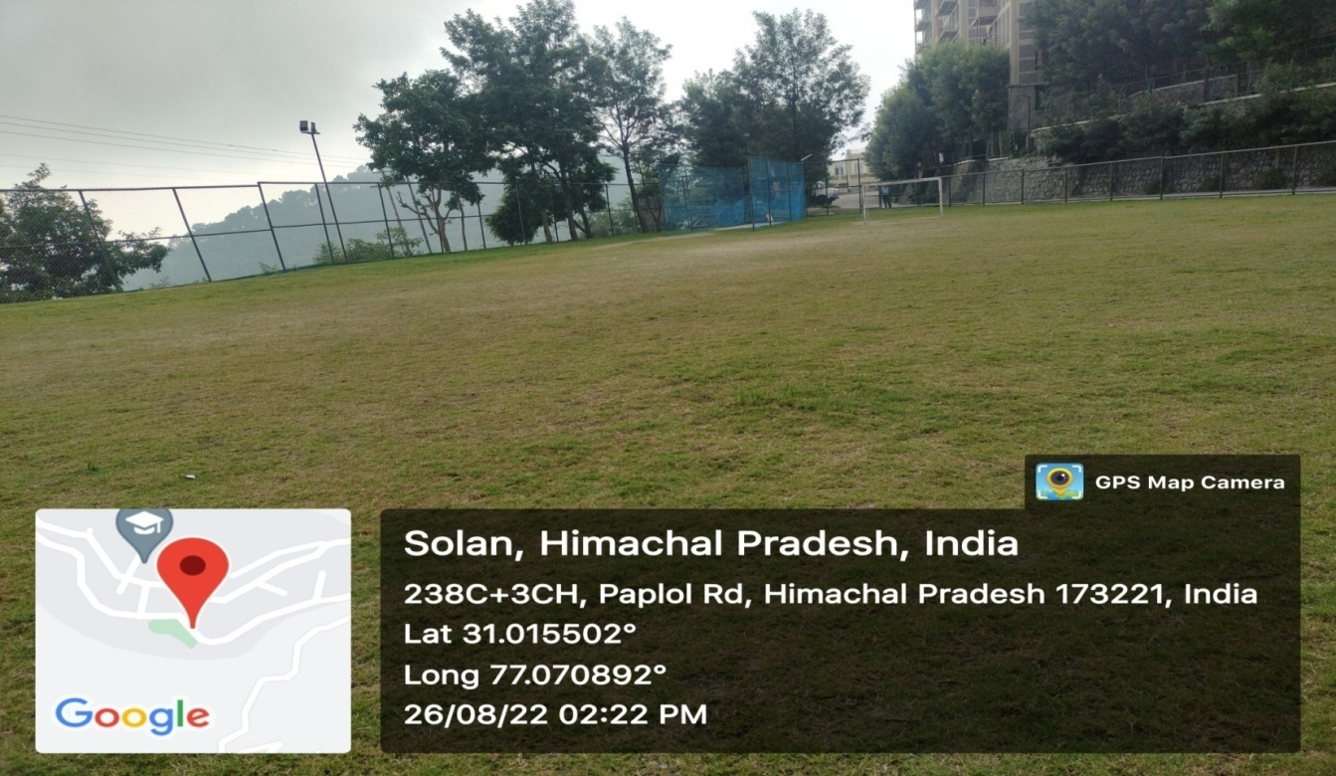

Students Gym – Image - 1
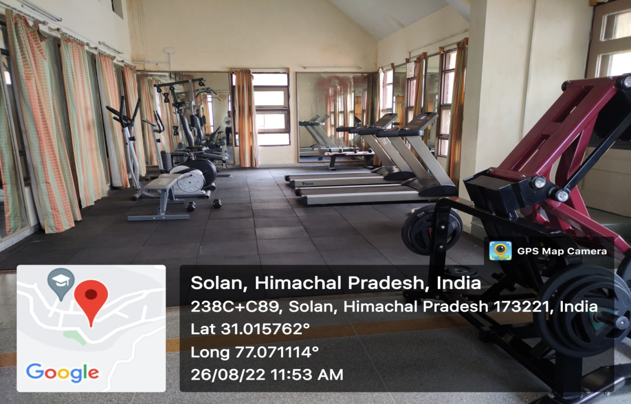

Students Gym – Image – 2
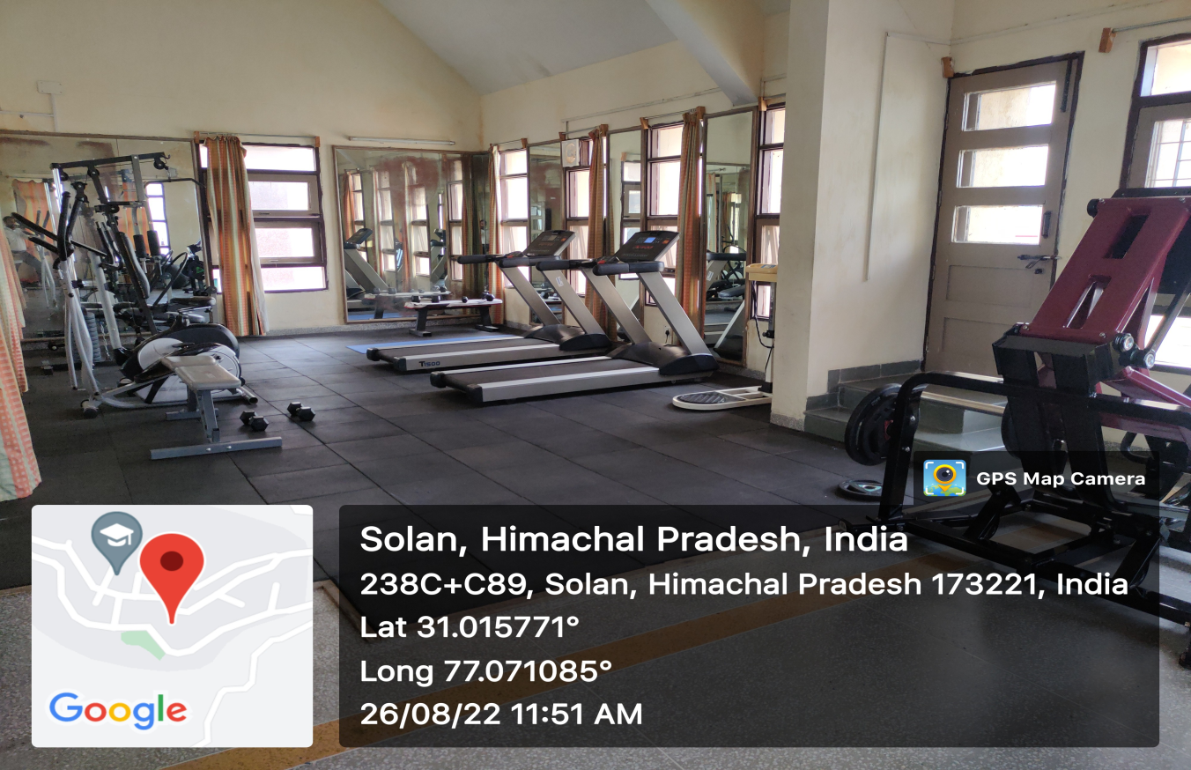

Table Tennis Image -1
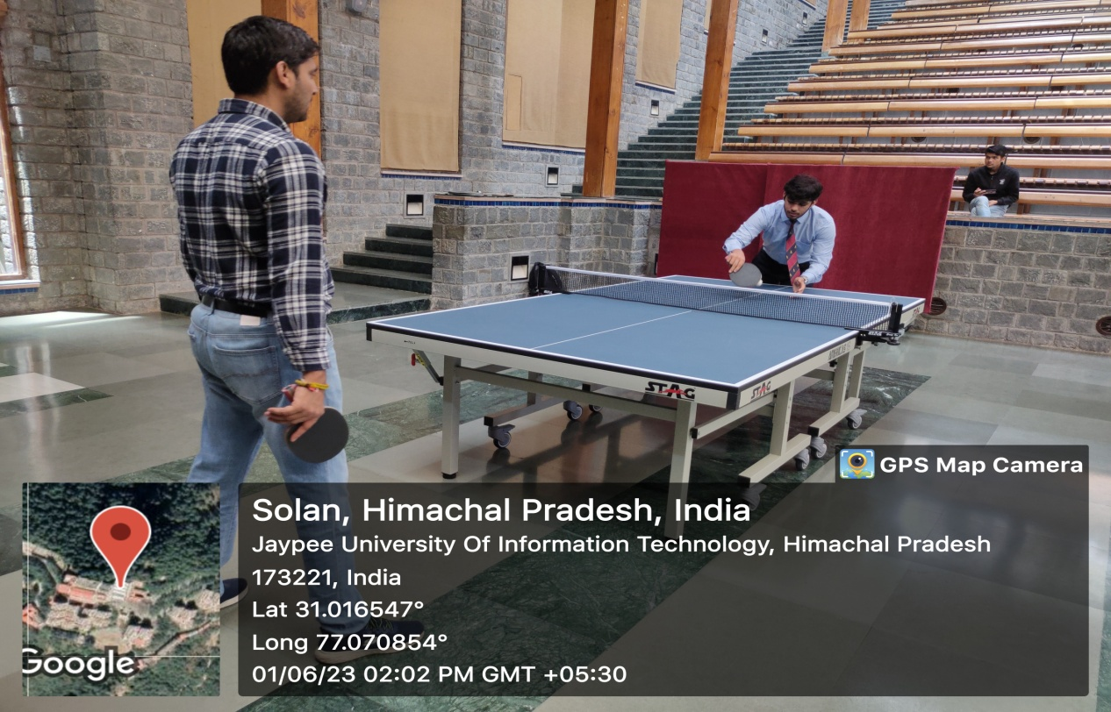

Table Tennis Image -2
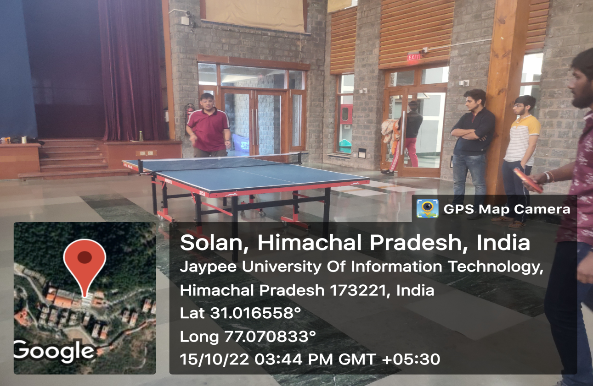

Volleyball Court – Image 1
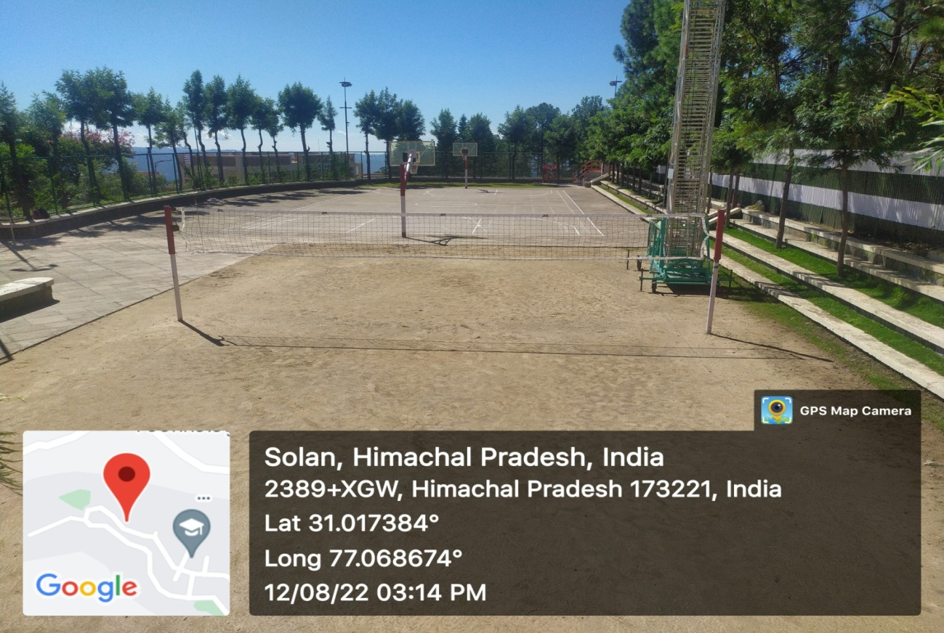

Volleyball Court – Image 2
